**Demo Merging Branches in Git and GitHub Repo**

**Objective:** To demonstrate how to merge branches in Git to integrate changes from one branch into another while maintaining a cohesive codebase and version history

**Tools required:** Git and GitHub

**Prerequisites:** We must have Git installed to proceed with this demo.

Steps to be followed:

1. Create a new GitHub repository
2. Clone the GitHub repository
3. List all the branches in your repository
4. Create and switch to the new branch
5. Create a file and commit the changes
6. Check the status of the new branch
7. Switch back to the main branch
8. Merge the branches

**Step 1: Create a new GitHub repository**

* 1. Click on the **New button** to create a **new repository**



* 1. Enter a repository name and click on the **Create repository button**

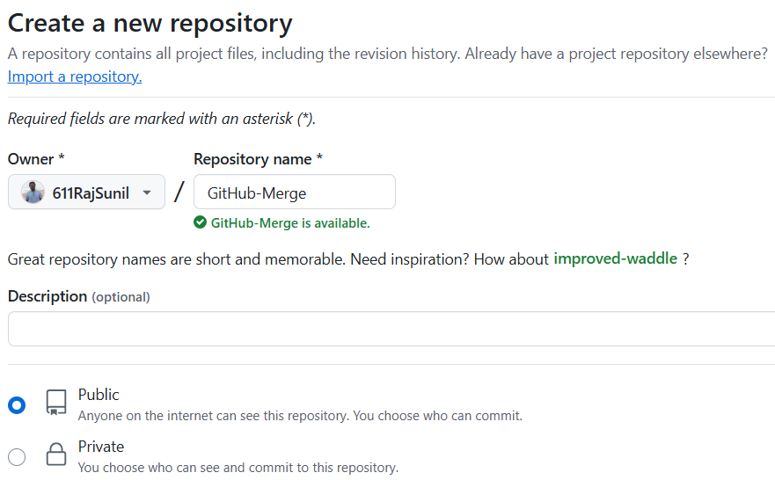

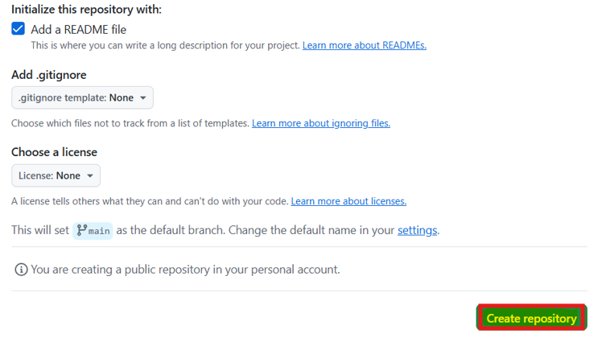

**Step 2: Clone the GitHub repository**

1. Open the created repository in GitHub and click on the **Code button**

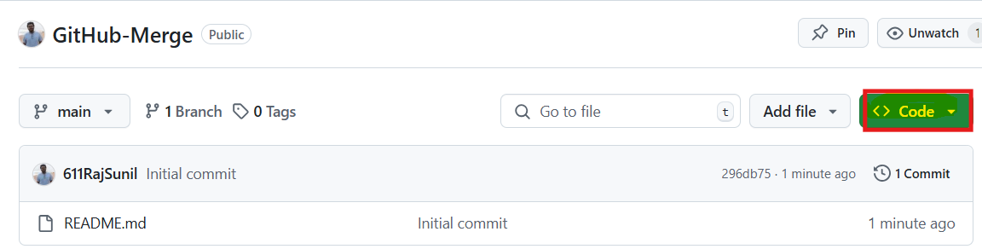

1. Click on the copy icon to copy the **HTTPS URL,** as shown below:

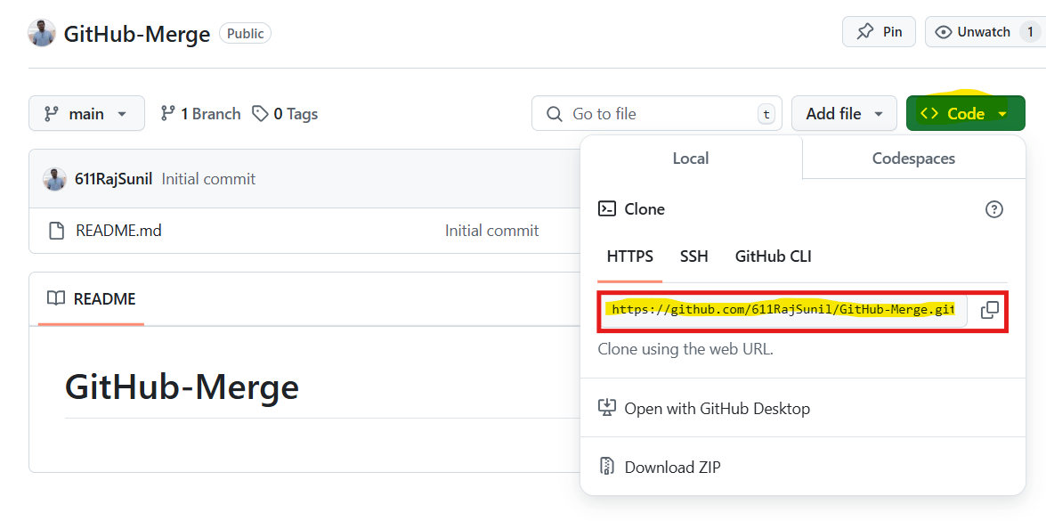

1. Open the terminal tab on your lab and use the following command to clone the repository: **git clone <URL>**

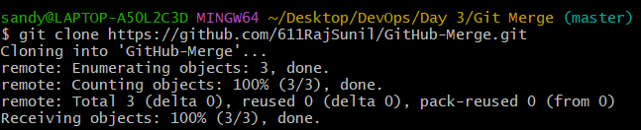

**Note: Replace the URL with the copied URL from the directory**

**Step 3: List all the branches in your repository**

1. Navigate to the cloned repository using the following command: **cd GitHub-Merge**

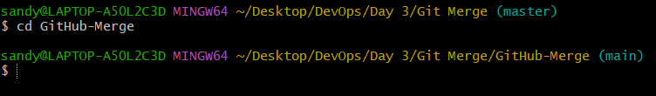

1. Run the following command to display all repository branches: **git branch**



**Step 4: Create and switch to the new branch**

**4.1** Run the following command to create a new branch in your repository: **git branch dev**



* 1. Use the following command to switch to the newly created branch: **git checkout dev**



**Step 5: Create a file and commit the changes**

* 1. Execute the given command to create a file: **vi index.html**



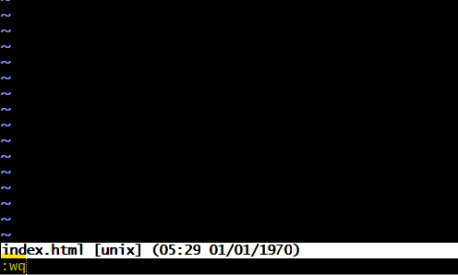

* 1. Add the given code snippet into the **index.html** file:

**<html>**

**<body>**

**<p> This is a Test HTML file. </p>**

**</body>**

**</html>**

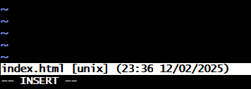

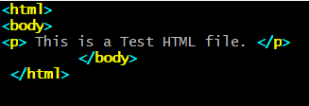

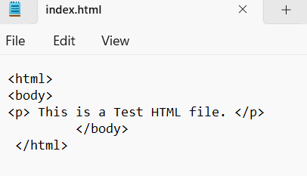

**Note: Press i to edit the files. Press the Esc button to exit insert mode and enter :wq to save the file**

* 1. Use the following command to add the file to the **dev** branch: **git add .**



* 1. Use the following command to commit the changes: **git commit -m "Added Index.html"**

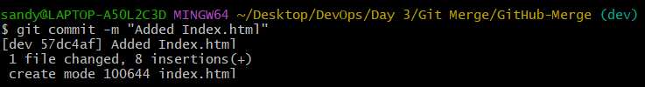

**Step 6: Check the status of the new branch**

* 1. Check the status of the new branch using the following command: **git status**

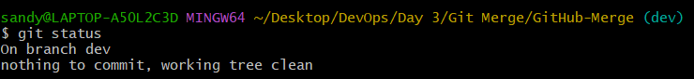

**Step 7: Switch back to the main branch**

* 1. Use the following command to switch back to the main branch: **git checkout main**

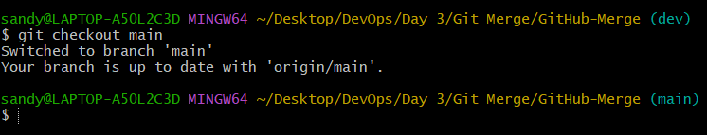

**Step 8: Merge the branches**

* 1. Use the following command to merge the dev branch to the main branch: **git merge dev**

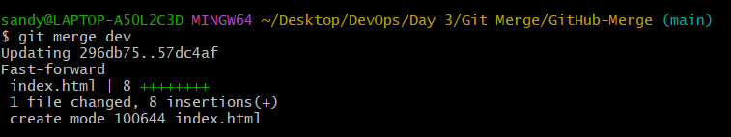

* 1. Push the changes to the remote repository using the following command: **git push origin main**

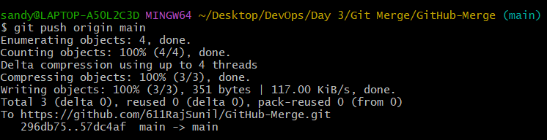

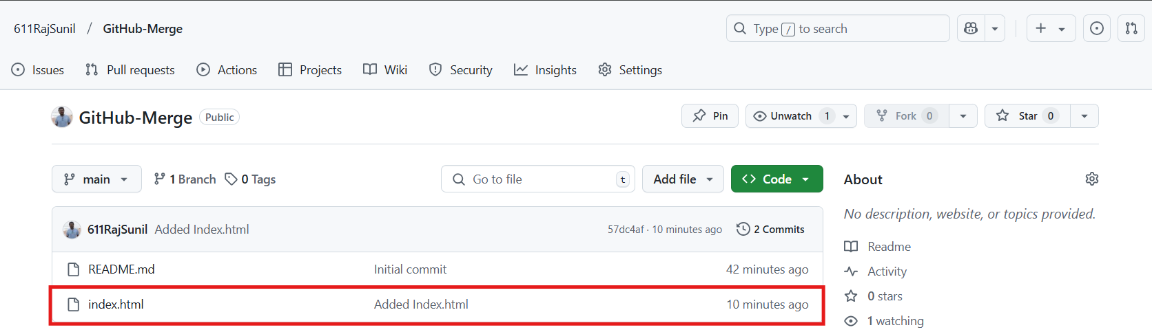

**By following these steps, you have successfully demonstrated merging branches in Git to integrate changes from one branch into another, while ensuring a cohesive codebase and version history.**